Interpreting Art: Frida Kahlo

Table # ____ Date _______
Student Names:

Answer these questions about the artwork you are viewing. Choose one student to write down what the group decides. Then, discuss the artwork as a group. Your group will share their writing with the class later.
I. What do you see?

II. What do you think the artwork might be about?

III. How do you know?

IV. Name 3 objects, symbols or images in the artwork. Tell what you think they might mean and WHY you think so (Refer to the artwork to answer)
1.
2.
3.

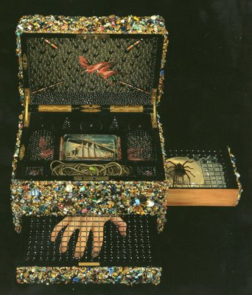
Interpreting Art: Lucas Samaras

Table # ____ Date _______
Student Names:

Answer these questions about the artwork you are viewing. Choose one student to write down what the group decides. Then, discuss the artwork as a group. Your group will share their writing with the class later.
I. What do you see?

II. What do you think the artwork might be about?

III. How do you know?

IV. Name 3 objects, symbols or images in the artwork. Tell what you think they might mean and WHY you think so (Refer to the artwork to answer)
1.
2.
3.

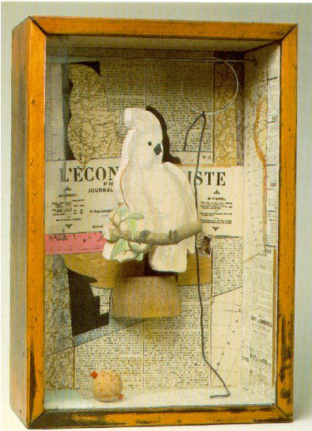
Interpreting Art: Joseph Cornell

Table # ____ Date _______
Student Names:

Answer these questions about the artwork you are viewing. Choose one student to write down what the group decides. Then, discuss the artwork as a group. Your group will share their writing with the class later.
I. What do you see?

II. What do you think the artwork might be about?

III. How do you know?

IV. Name 3 objects, symbols or images in the artwork. Tell what you think they might mean and WHY you think so (Refer to the artwork to answer)
1.
2.
3.

