Unit: Identity
Grade Level: 4

Lesson Overview:
The exemplars for this lesson are Frida Kahlo, Lucas Samaras and Joseph Cornell, three artists who explored the idea of personal identity through their art. Other similar artists are included if additional resources are desired. Students will interpret self portraits by these artists, both in a class discussion, and in groups using the artist writing worksheets. Samaras and Cornell created small "portrait" boxes that reveal as well as conceal identity through the use of objects and symbols. Kahlo created a series of self-portraits that include many personal and cultural symbols of her identity. Students will research the artists' lives and background, and then use the concepts of symbolic representation to present themselves by creating their own box that displays their own internal and external identity. Students will decorate their box and place their drawn self-portrait on the outside, inviting the viewer to find out more. They will then explore the concepts of visual symbols and metaphors and thoughtfully choose at least three items to represent their inner selves to go inside the box.
Students will discuss what an identity is and learn how personally selected symbols can illustrate aspects of a person's identity within an artwork. Students create an identity box called an Inside-Outside Box using assemblage and collage techniques, objects, images, art and a cigar box, and then peer-assess them with a writing assignment, a class critique, and teacher rubric to assess the boxes. Cigar boxes were donated for this unit by a local tobacco outlet.

Length of Lesson:
Seven 45-minute class periods

Instructional Objectives:
Students will:
- explore and interpret the work of Frida Kahlo, Lucas Samaras and Joseph Cornell, describe their use of diverse symbols and objects to signify new meaning and identity.
- define and compile materials that explore personal and cultural identity.
- create "identity boxes", with artistic representation of their internal and external identity.

Essential Questions
(bold items will be posted in the classroom during the unit)

1. What is an identity?

2. What are ways that artists reveal their identity in their artwork?
· What are ways that artists show aspects of their identity using both realistic and symbolic representations?
· How do artists go beyond showing us what they look like?
· What do artists add to their works to hide clues about who they really are or how they feel? (example: Kahlo added wounded animals to express her physical pain)

3. How can you reveal your identity in your art?
· How can you show aspects of your identity using both realistic and symbolic representations?
· How can you go beyond showing us what you actually look like?
· What symbols, animals, colors, and objects can you use to show your identity? Why?
· What can you add to your artwork that can give clues about who you really are and how you feel?

Learning Activities;
Lesson 1
Students
- discuss the big idea of identity and use of personal symbols to express identity
· brainstorm personal symbols (take attached survey, write a list or thinking map); brainstorming includes items such as what animal do they see themselves as (and why), what color symbolizes their identity, and what objects could be metaphors for aspects of their identity?
· make a self-portrait sketch using at least five of the symbols from the brainstorming session

Lesson 2
Students:
· use the SMART Board to view and discuss PowerPoint presentation of the self-portraits of Kahlo, Samaras and Cornell
· describe how the artist has depicted aspects of their identity using symbols, metaphors or allegories such as Kahlo's Wounded Deer where she used a deer with a human head to represent aspects of her life
· after commenting on the artist's work, describe what they would use to depict aspect of their life; for example, when talking about the plastic spider in one of Samaras' self-portrait assemblages, students would say what object they would use to communicate an aspect of their identity and why.

Lesson 3
· students select a cigar box to create an inside-outside identity box.
· On the outside they are to add a photo of themselves, artwork, objects, and text that shows how they are on the outside
· on the inside of the box, they are to add some of their symbols of themselves they created in lesson one as well as 3 personally significant objects, as well as text and photos from home that shows how they really are on the inside of their identity. Two coats of Modge Podge will add a layer of transparent protection and sheen to the finished boxes.

Assessment
When their identity boxes are finished:
· Students will first write an essay about what they were communicating about their identity and then fold the paper half way to hide what they wrote. They will exchange it with a peer who will write about what they think is being expressed about the artist's identity without reading what the artist wrote ahead of time.
· The class will select several boxes to critique; students who are not the artist will say what they think the student artist is communicating on the outside and on the inside about their identity and why they came to that conclusion. The student artist will respond and describe what they were in fact trying to express
· To assess the boxes, the teacher will use a rubric. Items will include how effectively the student communicated aspects of their identity using mostly non-representational means and craftsmanship and overall aesthetic quality of the box

South Carolina Standards
I. Understanding the Visual Arts in Relation to History and Cultures
Students will
A. Identify specific artworks and styles as belonging to particular artists, cultures, periods, and places.
II. Using Knowledge of Structures and Functions
Students will
B. Select and use various elements and principles of design to communicate personal ideas in their artworks.
III. Understanding and Applying Media, Techniques, and Processes
Students will
B. Use a variety of media, techniques, and processes to communicate ideas, experiences, and stories through their artworks.

Materials:

Cigar type boxes or flat small shoeboxes with lids
Images of Kahlo, Samaras and Cornell's artwork
Variety of small objects, text, and images from magazines
Paper
Pencils
Construction paper
Inexpensive craft items
Glue
Markers
Modge Podge
Variety of small, personally symbolic objects
Images from magazines
Personal photos

Identity Box Rubric
How did I do? | Excellent | Good | Fair | Needs Work
What do my images mean? | I effectively interpreted how the items in my collection related to many different aspects of my personality with original examples | I interpreted how items in my collection related to a few aspects of my personality with examples | I incompletely interpreted how the items in my collection related to aspects of my personality | I failed to interpret any connection between the items in my collection and how they relate to my personality
Did I learn what the artists’ symbols mean? | I raised questions and effectively investigated how the artist’s symbols express different aspects of their identity | I adequately investigated how the artist’s symbols express an aspect of their identity | I partially investigated the artist’s symbols but did not clearly relate them to aspects of their identity | I did not investigate how the artist’s symbols relate to aspects of their identity
Did my use of materials and media connect to my identity? | Many different aspects of the medium and design clearly point to my identity in an imaginative way | Some aspects of the medium and design clearly point to my identity | Aspects of the medium and design were hard to connect to my identity | My use of medium and design were disconnected to my identity

Assessment Task

Overview of the unit: Students interpret symbolic self portraits by several artists. They will discuss what an identity is and how artists have used personal symbols as well as metaphors, allegories, and objects (personification) to express aspects of identity in non-representational ways and write about it. Students create an identity box called an Inside-Outside box using assemblage and collage techniques, objects, images, art and a cigar box, and then peer- interpret and assess them with writing assignments. A student rubric based on the essential questions and final class critique follows.

Directions to Students for the 2 Assessment Tasks:
Task 1: Essential Question #2: "Think about the 3 artists we have studied; Kahlo, Samaras and Cornell. In writing, choose one of the artists, and describe 3 ways how the artist used symbols or metaphors to express their identity."
There will be 3 separate worksheets for the writing assignment, one for each of the 3 artists. The questions are the same for each sheet; you will select one of these. One thumbnail of an artwork from each artist we discussed will be on the sheet and it will be numbered from 1-3. You will circle 3 symbols, metaphors or parts of the artwork on the thumbnail. Then, you will write about and describe how the artist used the symbol or metaphor to tell you about their identity using at least three sentences each. Include how each message made you feel.

Task 2: Essential Question #3:
Explain the following in writing:

1. Explain how 3 of your images, symbols, or personally significant objects on your Identity Box tell about your identity.

Here are some examples of how you could answer this question:
"I attached my drawing of myself as a cheetah because I am very fast, a good hunter and runner" or
"I used the color yellow to decorate the outside of my box because I am a happy bright person who loves sunflowers"
"I glued my sketch of a broken heart because I lost my mother and it broke my heart. I put it on the inside of the box because most people don't know this about me because I am always smiling."

2. Describe how you communicated the way you view yourself on the outside and how you really are on the inside.

For example, you collaged your smiling photo on the outside but drew yourself sad on the inside of your box because you hide your broken heart).

Fold the paper half way (the long way) to hide what you wrote when you are finished. Exchange it with a classmate along with your box. They will write about what they think you are expressing on the outside about how others might see you and what they think you are expressing on the inside of your box about who you are inside. You will read what your peer has written and add a final statement about how effectively you have communicated who you are, both inside and out.

Criteria:
1. Did you explain how 3 different objects in your collection relate to 3 parts of your outward identity and 3 parts of your inward identity? Refer to the examples above if needed.
2. Did you choose one of the artists we studied and describe in writing 3 ways the artist used symbols or metaphors to tell about their identity?
3. Media/Craftsmanship: how effective is your use of media and your craftsmanship in expressing your identity?

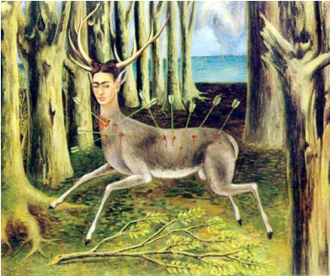
Interpreting Art: Frida Kahlo

Table # ____ Date _______
Student Names:

Answer these questions about the artwork you are viewing. Choose one student to write down what the group decides. Then, discuss the artwork as a group. Your group will share their writing with the class later.
I. What do you see?

II. What do you think the artwork might be about?

III. How do you know?

IV. Name 3 objects, symbols or images in the artwork. Tell what you think they might mean and WHY you think so (Refer to the artwork to answer)
1.
2.
3.

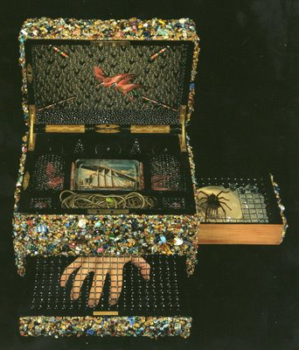
Interpreting Art: Lucas Samaras

Table # ____ Date _______
Student Names:

Answer these questions about the artwork you are viewing. Choose one student to write down what the group decides. Then, discuss the artwork as a group. Your group will share their writing with the class later.
I. What do you see?

II. What do you think the artwork might be about?

III. How do you know?

IV. Name 3 objects, symbols or images in the artwork. Tell what you think they might mean and WHY you think so (Refer to the artwork to answer)
1.
2.
3.

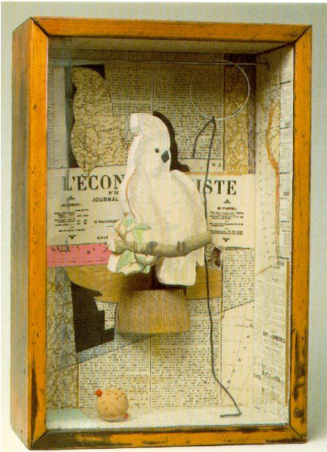
Interpreting Art: Joseph Cornell

Table # ____ Date _______
Student Names:

Answer these questions about the artwork you are viewing. Choose one student to write down what the group decides. Then, discuss the artwork as a group. Your group will share their writing with the class later.
I. What do you see?

II. What do you think the artwork might be about?

III. How do you know?

IV. Name 3 objects, symbols or images in the artwork. Tell what you think they might mean and WHY you think so (Refer to the artwork to answer)
1.
2.
3.

you can research this lesson plan further at: http://artsedge.kennedy-center.org/content/3807/

